|  |  |  |  |  |  |  |  |  |  |  |  |  |  |  |  |  |  |  |  |  |  |  |  |  |  |  |  |  |  |  |  |  |  |
| --- | --- | --- | --- | --- | --- | --- | --- | --- | --- | --- | --- | --- | --- | --- | --- | --- | --- | --- | --- | --- | --- | --- | --- | --- | --- | --- | --- | --- | --- | --- | --- | --- | --- |
| **FORMULIR AKUISISI PROPERTI APARTEMEN – MNC Play** | | | | | | | | | | | | | | | | | | | | | | | | | | | | | | | | | |
| Nama Properti | | | |  | | | | | | | | | | | | | | | | | | | | | | | | | | | | | |
| Alamat | | | | RT. RW. Kec.  Kel. Wil. Kota | | | | | | | | | | | | | | | | | | | | | | | | | | | | | |
| Koordinat | | | |  | | | | | | | | | | | | | | | | | | | | | | | | | | | | | |
| Status Bangunan | | | | Strata Title Service Apartment | | | | | | | | | | | | | | | | | | | | | | | | | | | | | |
| Existing / Sdh Terbangun | | | | | | | | | | | | | | | | | | Launch DD/MM/YY : | | | | | | | | | | | |
| On Progress/Dlm P embangunan | | | | | | | | | | | | | | | | | |
| **Tower** | | | | **1** | | | **2** | | | **3** | | **4** | | | **5** | | | **6** | | | | **7** | **8** | | | | **9** | | **10** | | | **Total** | |
| Jumlah Lantai | | | |  | | |  | | |  | |  | | |  | | |  | | | |  |  | | | |  | |  | | |  | |
| Jumlah Unit | | | |  | | |  | | |  | |  | | |  | | |  | | | |  |  | | | |  | |  | | |  | |
| Jumlah Yang Dihuni | | | |  | | |  | | |  | |  | | |  | | |  | | | |  |  | | | |  | |  | | |  | |
| Tingkat Okupansi *(diisi MKM)* | | | |  | | |  | | |  | |  | | |  | | |  | | | |  |  | | | |  | |  | | |  | |
| Jumlah Unit Area Komersial | | | |  | | |  | | |  | |  | | |  | | |  | | | |  |  | | | |  | |  | | |  | |
| Jumlah Area Komersial Dihuni | | | |  | | |  | | |  | |  | | |  | | |  | | | |  |  | | | |  | |  | | |  | |
| Tingkat Okupansi *(diisi MKM)* | | | |  | | |  | | |  | |  | | |  | | |  | | | |  |  | | | |  | |  | | |  | |
| Jumlah Kendaraan Terdaftar  *(Mobil – Motor)* | | | |  | | |  | | |  | |  | | |  | | |  | | | |  |  | | | |  | |  | | |  | |
| Type Unit *(isi dengan angka)* | | | | Studio ( ) 1 BR ( ) 2 BR ( ) 3 BR ( ) Penthouse ( ) | | | | | | | | | | | | | | | | | | | | | | | | | | | | | |
| Average Harga Unit | | | | Terendah, Rp. Tertinggi, Rp. | | | | | | | | | | | | | | | | | | | | | | | | | | | | | |
| Infrastruktur | | Yang tersedia | | Coaxial | | | | | | | FTTH | | | | | | | | ADSL | | | | | | UTP | | | | | | Belum Ada | | |
| Kepemilikan  *Coret yang tdk perlu* | | BM | Operator | | | | | | | BM | Operator | | | | | | | | BM | Operator | | | | | | BM | Operator | | | | | |
| Bersedia Re-wiring FTTH | | | | YA TIDAK | | | | | | | | | | | | | | | | | | | | | | | | | | | | | |
| Main Hole Ready | | | | Di Unit YA TIDAK | Di Koridor YA TIDAK | | | | | | | | | | | | | | | | | | | | | | | | | | | | | |
| Pembangunan Akses s/d. | | | | Control Room Shaft (FAT) Koridor (DW) Unit (TB) | | | | | | | | | | | | | | | | | | | | | | | | | | | | | |
| Layanan Yang Disediakan MKM | | | | Internet IPTV Telephony* | | | | | | | | | | | | | | | | | | | | | | | | | | | | | |
| **Profile Penghuni** | | | | | | | | | | | | | | | | | | | | | | | | | | | | | | | | | |
| Komposisi Kewarganegaraan Penghuni | | | | | Expatriat ( %) Mayoritas Negara: | | | | | | | | | | | | | | | | | | | | | | | | | | | | |
| Indonesia ( %) | | | | | | | | | | | | | | | | | | | | | | | | | | | | |
| Jenis Pekerjaan | | | | | Mahasiswa ( %) Karyawan ( %) Pengusaha ( %) | | | | | | | | | | | | | | | | | | | | | | | | | | | | |
| Status Penghuni | | | | | Single ( %) Keluarga ( %) | | | | | | | | | | | | | | | | | | | | | | | | | | | | |
| **Provider Existing** | | | | | **Berikan tanda cek list** | | | | | | | **Eksklusif** | | | | | **Durasi Kerjasama s/d. Bln/Thn** | | | | | | | | | **Skema Kerjasama** | | | | | | | |
| **Inet** | | | **TV** | | **Telp.** | | **Y** | | **N** | | | **Rev.Share (%)** | | | | **Sewa Lahan**  **(Rp.)** | | | |
| 1. |  | | | |  | | |  | |  | |  | |  | | |  | | | | | | | | |  | | | |  | | | |
| 2. |  | | | |  | | |  | |  | |  | |  | | |  | | | | | | | | |  | | | |  | | | |
| 3. |  | | | |  | | |  | |  | |  | |  | | |  | | | | | | | | |  | | | |  | | | |
| 4. |  | | | |  | | |  | |  | |  | |  | | |  | | | | | | | | |  | | | |  | | | |
| 5. |  | | | |  | | |  | |  | |  | |  | | |  | | | | | | | | |  | | | |  | | | |
| **Skema kerjasama dengan MNC Play** | | | | | | | | | | | | | | | | | | | | | | | | | | | | | | | | | |
| Status Kerjasama/Periode | | | | | Exclusive Non Exclusive Thn | | | | | | | | | | | | | | | | | | | | | | | | | | | | |
| **Aktifitas Sales & Marketing Tools** | | | | | | | | | | | | | | | | | | | | | | | | | | | | | | | | | |
| Penempatan/Pemasangan/  Penyebaran Marketing Tools | | | **Lobby** | | | | | | **Basement** | | | | **Pintu parkir in/out** | | | **Lift** | | | | **Swm. Pool** | | | | **Fitness**  **Center** | | | | **Cust. Service** | | | | | **Receptionist** |
| Aktifitas Sales Probing | | |  | | | | | |  | | | |  | | |  | | | |  | | | |  | | | |  | | | | |  |
| Pop Up Table *(terlampir)* | | |  | | | | | |  | | | |  | | |  | | | |  | | | |  | | | |  | | | | |  |
| Penempatan Spanduk *(terlampir)* | | |  | | | | | |  | | | |  | | |  | | | |  | | | |  | | | |  | | | | |  |
| Penempatan Poster *(terlampir)* | | |  | | | | | |  | | | |  | | |  | | | |  | | | |  | | | |  | | | | |  |
| Sticker Pintu Lift *(terlampir)* | | |  | | | | | |  | | | |  | | |  | | | |  | | | |  | | | |  | | | | |  |
| X/Roll Up Banner *(terlampir)* | | |  | | | | | |  | | | |  | | |  | | | |  | | | |  | | | |  | | | | | **√** |
| Acrilic Box /Brosur *(terlampir)* | | |  | | | | | |  | | | |  | | |  | | | |  | | | |  | | | |  | | | | | **√** |
| Catatan: | | | | | | | | | | | | | | | | | | | | | | | | | | | | | | | | | |
| Saya yang bertandatangan menyatakan bahwa informasi ini adalah benar adanya, untuk kebutuhan follow up kerjasama yang cepat secara detail dan akurat. | | | | | | MNC Play  (..................................................)  Jabatan: | | | | | | | | | | | | | | | Pihak Mitra  Tgl.  (..................................................)  Jabatan:  No.Telp.  No.HP. | | | | | | | | | | | | |

|  |  |
| --- | --- |
| Catatan dan Rekomendasi Sales Mgr./GM MKM.  Rekomendasi : REJECT DROP APPROVE | Jakarta, _____________________  (..................................................)  Jabatan: |

* Optional | Catatan: Beri tanda Cek (√) pada kolom pilihan dan coret yang tidak perlu

REJECT : Proyek tidak direkomendasikan secara permanen

DROP : Proyek tidak direkomendasikan namun dapat di follow up kembali

APPROVE : Proyek disetujui dan dapat dilanjutkan

**POP UP TABLE**

*Ukuran 184 cm x 90 cm*

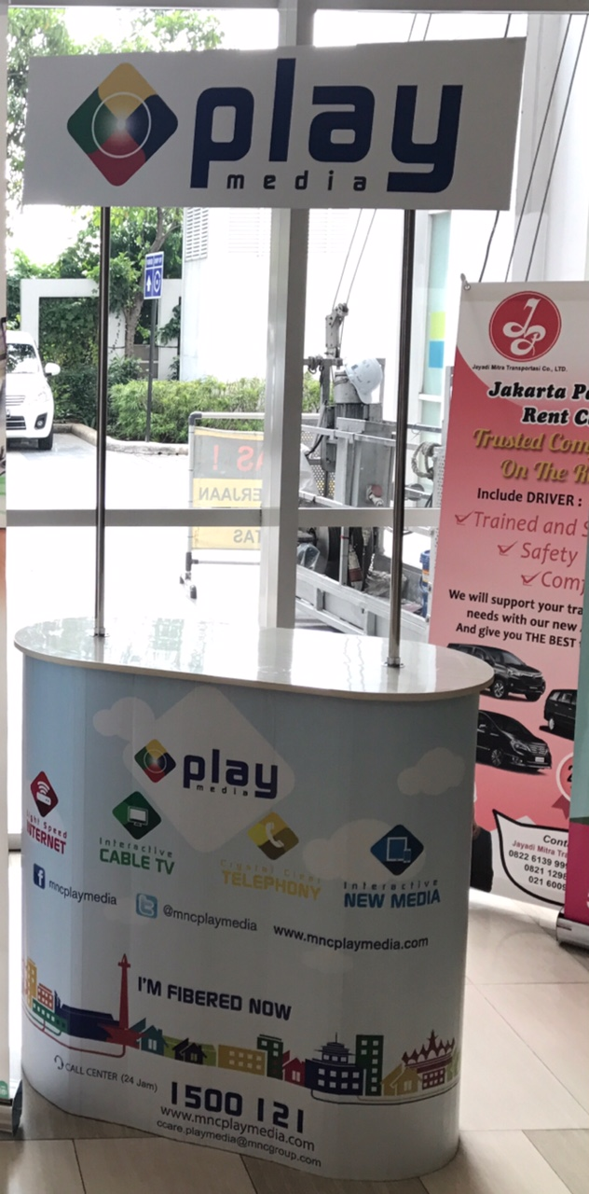

**POSTER**

*Ukuran 118,9 cm x 84,1 cm*

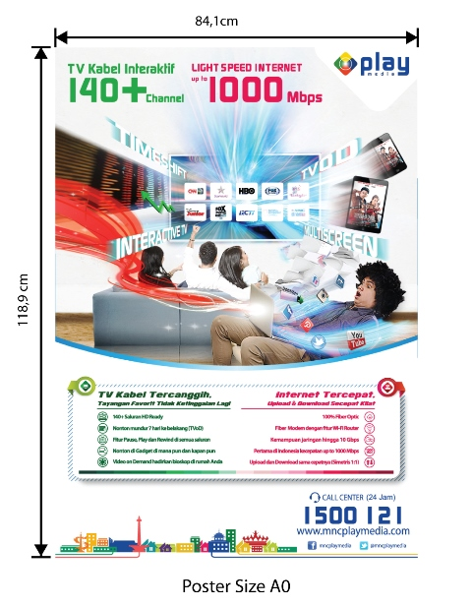

**ACRILIC BOX /Brosur**

*Ukuran 20 cm x 30 cm x 5 cm*

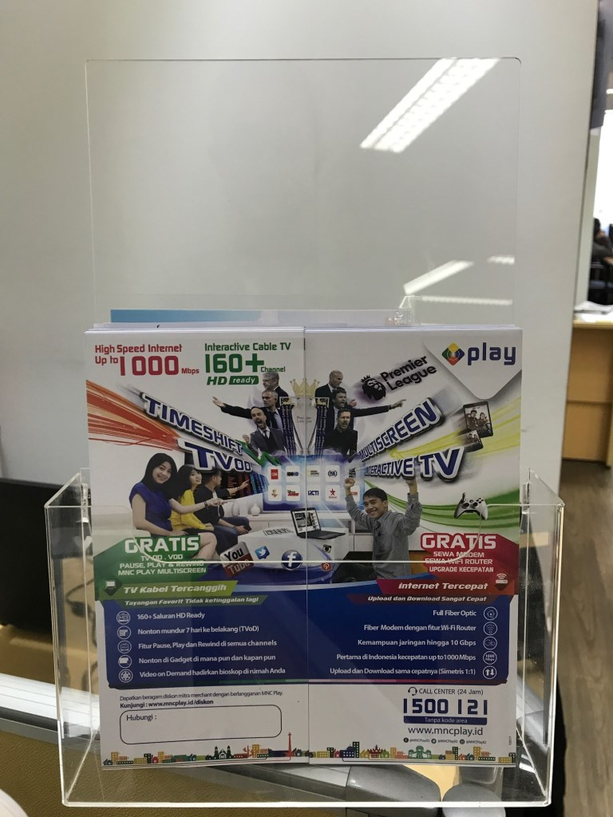

**X/ROLL UP BANNER**

*Ukuran 200 cm x 80 cm*

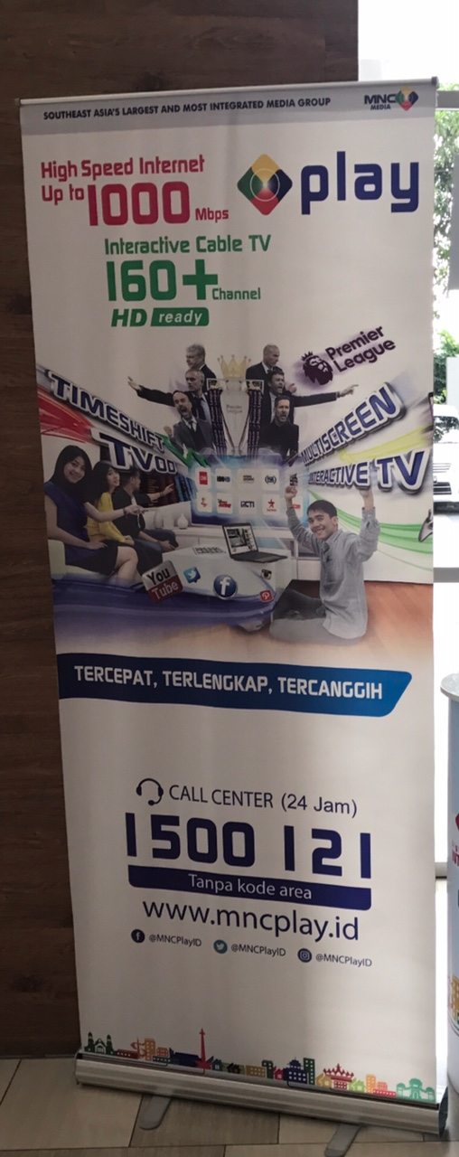

LIFT EKSTERIONR STICKER BRANDING

(*Ukuran disesuaikan dengan kondisi lift*)

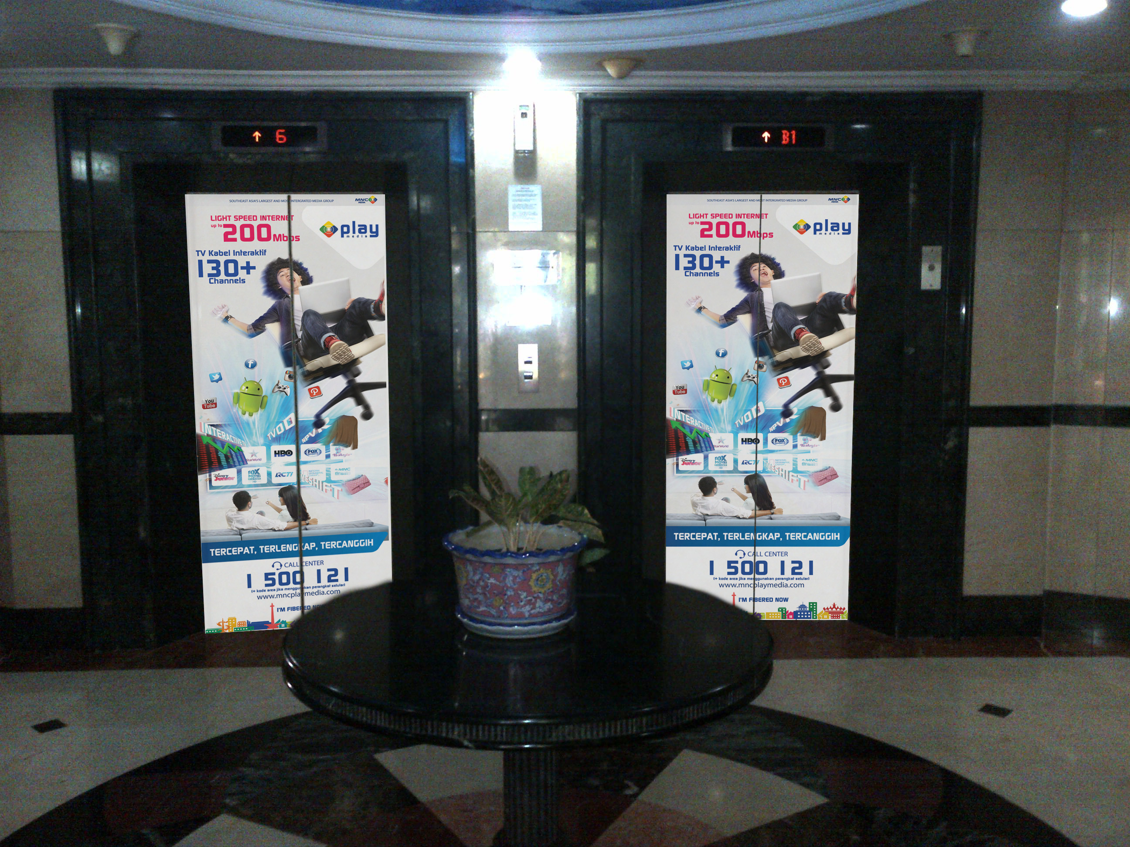

**SPANDUK**

*(ukuran 2 x 4 m / disesuaikan)*

*Catatan:*

*Design, content atau redaksi serta ukuran pada material marketing tools diatas adalah merupakan ilustrasi semata. Design, content atau redaksi serta ukuran yang akan digunakan sebagai materi promosi akan mengikuti atau disesuaikan dengan kondisi yang ada.*